30 people were given snacks to eat while they were at a “Healthy Choices” luncheon. They were then asked to rate their snacks on a 1 (not healthy) to 10 (very healthy) point scale. The ratings are below.

cheese candy fruit

6 3 4

7 2 5

8 3 6

6 4 5

5 2 4

6 1 7

7 2 6

6 3 5

5 4 3

7 3 6

Is there a significant difference (using p<.05) in the ratings for snacks?

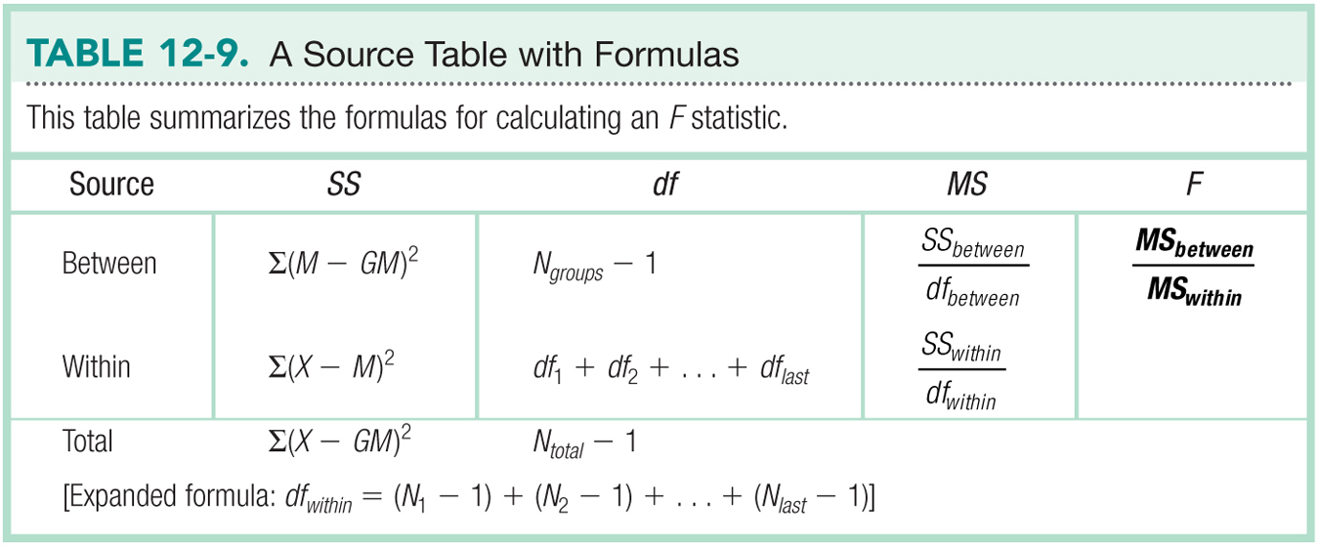

|  |  |  |  |  |
| --- | --- | --- | --- | --- |
| Variance Type | SS | *df* | *MS* | *F* |
| Between groups  (IV) |  |  |  |  |
| Within Groups  (error) |  |  |  |  |
| Total |  |  |  |  |

|  |  |
| --- | --- |
| Step 1 |  |
| Step 2 |  |
| Step 3 |  |
| Step 4 |  |
| Step 5 |  |
| Effect Size |  |

Tukey Post Hoc

|  |  |  |  |  |
| --- | --- | --- | --- | --- |
| Group 1 | Group 2 | P-value | Comparison | Reject? |
|  |  |  |  |  |
|  |  |  |  |  |
|  |  |  |  |  |

Bonferroni Post Hoc

|  |  |  |  |  |
| --- | --- | --- | --- | --- |
| Group 1 | Group 2 | P-value | Comparison | Reject? |
|  |  |  |  |  |
|  |  |  |  |  |
|  |  |  |  |  |